Data Research Analysis:

A range consisting of pre-determined assumptions is built on orbital and proximal relationship between the Sun and Earth, with a primary emphasis on a type of temperature effect the energy radiating star is having on the planet.

Coinciding the possibilities of man-made pollution as an addition to global temperature effect.

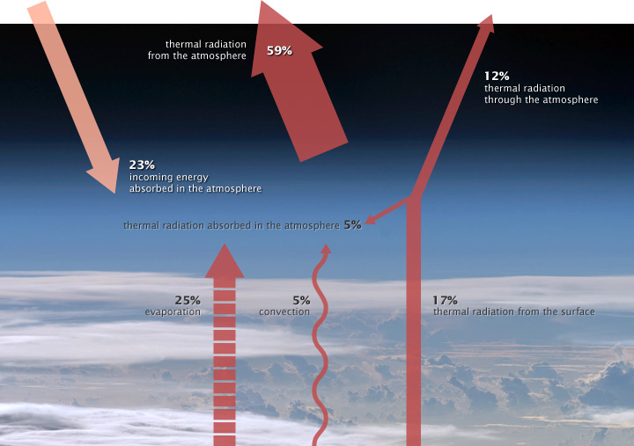

ILLUSTRATION OF THE ATMOSPHERE ENERGY BUDGET. PERCENTAGES VARY

(NASA illustration by Robert Simmon. Astronaut photograph [ISS017-E-13859.](http://eol.jsc.nasa.gov/scripts/sseop/photo.pl?mission=ISS017&roll=E&frame=13859))

**Steps taken to achieve the resolution:**

1. Pre-Determining the basic assumptions in the Global Warming case:
2. Assumption, the decrease in the distance from Earth to the Sun produces a global warming. The sun is in a moving rotating orbiting motion around the galaxy. Similar way Earth rotates in a variable orbital direction and velocity and elliptical distance and path, all while performing gravitational orbiting motion around the sun. The shift or even a slight alteration in the revolution distance of earth-round-sun orbit causes the distance from the sun to earth shortened and triggers the increased warming effect on a year to year comparison basis.
3. Assumption, the warming effect is caused by lower atmosphere trapped carbon dioxide gasses confining the heat radiation gases to the planets greenhouse, resulting in an increased warming effect.
4. Assumption, the Aerosol-mixed particles, gasses and droplets formed in vapors contribute to potential global warming effect.
5. Performing online research in obtaining and forming the required data into data sets. In case of a Global Warming, the objective is to determine the leading contributing cause.
6. Researching and selecting the required related measurements to track the Global Geo-Thermal scene within a predetermined time period.
7. Recognizing various patterns while forming the relational data sets based on pre-determined assumptions and visualizing the output onto plots. Searching for relationship patterns between the key measurement parameters.
8. Building a conclusive case based on the discoveries and forming a concurring judgement for each presumed assumption.

During the case study, the project experienced issues obtaining **pre-determined fully filled data set parameters**, including:

* Encountering unknown Data Range Variables
* Locating Official Scientific Data Sources
* Relating Available Scientific Measurements
* Accepting Primary Scientific Data Collection Methods and Inconsistencies

**The Data Sets Primary data is set on 4 planetary measurements in units:**

* Surface Temperatures Levels in Degrees Celsius
* Total Solar Irradiances (TSI) in Watts/m2
* Atmospheric Co2 Gas Levels in parts-per-million(ppm)
* Atmospheric Aerosols Particle Levels particulate matter—(pm)

**Obtaining types of data sets vital parameters:**

* Dates ranging from 01-01-1970 to 01-01-2019
* Monthly (12 months) Global Average Surface Temperature
* Monthly (12 months) Global Average Carbon (Co2) concentration in atmosphere
* Monthly (12 months) Global Average Total Solar Irradiance in atmosphere
* Monthly (12 months) Global Average Aerosols concentration in atmosphere

**Locating the cause and effect relationship between:**

* Surface Temperature vs Atmospheric Co2 Gas Levels
* Surface Temperature vs Total Solar Irradiance Levels
* Surface Temperature vs Atmospheric Aerosols Particle Levels
* Atmospheric Aerosol vs Atmospheric Co2 Gas Levels
* Atmospheric Co2 Gas vs Total Solar Irradiance Levels
* Atmospheric Aerosol vs Total Solar Irradiance Levels>>>>….
* Surface Temperature vs Time
* Total Solar Irradiance vs Time
* Atmospheric Aerosol vs Time
* Atmospheric Co2 vs Time

**Concluding with a Final Analysis based on the collected data for each presumed assumption:**

1. Assumption- Atmospheric Total Solar Irradiance (distance to the Sun)

Primary Scientific Data Collection Method and Inconsistencies:

The distance from earth to sun is approximated by various methods.

All of the methods are only estimations. The Sun absorbs any frequency of the incoming wave signal with a null rate of reflection. Simply, a wave signal from the Sun will not beacon back to the radar stations on Earth. A measurement is performed by assuming the planet Venus is making a symmetric circle around the sun, by echoing back a signal from Venus, then measuring the relational distance to the sun. This method is indirect. True alternating distances from Sun to Earth are unknown.

Total Solar Irradiance (TSI) calculates total solar power radiating from planet Earth in any frequency above the atmospheric levels of earth. Data ranging from 2003-present is calculated by a radiometer onboard the SORCE Satellite. Equipment calibrations is an ongoing effort. Prior to 2003 the TSI data is a historical reconstruction based on various proxy-model data sources.

Total Solar Irradiance is selected for our research study as a measure for the Assumption A as suitable due to:

* The calculation formula containing mean solar position distance, representing the approximated timely distances between the Sun and Earth.
* The spectrum imagining monitor presents the solar radiation levels measurements

In the upper atmosphere.

By applying the measurement data to the formula sets, research project can attempt to build a relationship between Earth’s:

* Time and total irradiated solar energy (TSI) from the planet.
* Surface Temperatures and total irradiated solar energy (TSI) from the planet.
* Atmospheric Co2 Gas presence and total irradiated solar energy (TSI) from the planet.
* Atmospheric Aerosols Particle Levels and total irradiated solar energy (TSI) from the planet.

Based on the collected data and relationships comparisons in A. Assumption, the following statements can be accepted:

>>>>>>>>>>>>>>>>>>>>>>>>>>>>>>>>>>>>>>

Data retrieval source links:

http://lasp.colorado.edu/home/sorce/data/tsi-data/

<https://www.nasa.gov/mission_pages/sunearth/news/sorce-10yrs.html>

<http://curious.astro.cornell.edu/about-us/41-our-solar-system/the-earth/orbit/87-how-do-you-measure-the-distance-between-earth-and-the-sun-intermediate>

1. Assumption – Atmospheric Carbon Dioxide Gasses

Primary Scientific Data Collection Method:

Carbon dioxide (CO2) is an important heat-trapping (greenhouse) gas, which is released through human activities such as deforestation and burning fossil fuels, as well as natural processes such as respiration and volcanic eruptions.

CO2 data is measured by a scientific institution at the Mauna Loa Observatory (MLO) on the Big Island in Hawaii USA by the National Oceanic and Atmospheric Administration (NOAA).

Flask collection method for global atmospheric measurement of CO2:

Air sample on the surface level is collected into tightly sealed bottle and is used to gather the detailed information on carbon cycling by measuring the CO2 concentration. Collected samples are examined by the laboratory. The CO2 is separated from other gasses and the concentration levels are thoroughly measured by a mass spectrometer.

Space-based collection method for global atmospheric measurement of CO2:

A satellite network equipped with various optical measuring equipment that scan and direct infrared energy from the Earth into the data collecting instrument.

Data Collection Method Inconsistencies:

Both the flask and space-based collection are indirect methods of systematic data gathering on the tropospheric and stratospheric levels. After all, the lower part of the Earth’s atmosphere is where the greenhouse carbons are apparently being trapped.

In addendum with the satellite and surface level collection methods, directly obtaining daily measurement of CO2 readings from the lower atmospheric levels around the globe will provide for more precise and concurrent data. Deploying stratospheric lighter-than-air aerostats or airships maybe a viable option.

By applying the measurement data to the formula sets, research project can attempt to build a relationship between Earths:

* Time and Atmospheric Co2 Gas Presence.
* Surface Temperatures and Atmospheric Co2 Gas Presence.
* Atmospheric Aerosols Particle Levels and Atmospheric Co2 Gas Presence.

Based on the collected data and relationships comparisons in B. Assumption, the following statements can be accepted:

>>>>>>>>>>>>>>>>>>>>>>>>>>>>>>>>>>>>>>>>>>>

Data retrieval source links:

<https://www.esrl.noaa.gov/gmd/ccgg/about/co2_measurements.html>

<https://co2.jpl.nasa.gov/>

1. Assumption – Atmospheric Aerosols

Primary Scientific Data Collection Method:

Atmospheric Aerosols are solid particles and liquid droplets specks of matter in the Earth atmosphere. Key aerosol groups include sulfates, organic carbon, black carbon, nitrates, mineral dust, and sea salt. The bulk of aerosols—about 90 percent by mass—have natural origins. Volcanoes eject huge columns of ash into the air, as well as sulfur dioxide and other gases, yielding sulfates. Sea salt and dust are two of the most abundant aerosols. The remaining 10 percent of aerosols are considered anthropogenic, or human-made. Aerosols and clouds seeded by them reflect about a quarter of the Sun’s energy back to space.

Scientists use an array of satellite, aircraft, and ground-based instruments to monitor aerosols. Radiometers, infrared and sun- photometer instruments quantify the amount of electromagnetic radiation and optical depth.

Data Collection Method Inconsistencies:

Aircraft and other ground stations deploy instruments that measure certain aerosol properties with greater accuracy but less frequently. Measuring particles within clouds remains challenging. Different types of particles can clump together to form hybrids that are difficult to distinguish. And changes in humidity or temperature can cause drastic changes in how certain aerosols behave and interact with cloud droplets.

By applying the measurement data to the formula sets, research project can attempt to build a relationship between Earths:

* Time and Atmospheric Aerosols Particle Levels
* Surface Temperature vs Atmospheric Aerosols Particle Levels

Based on the collected data and relationships comparisons in B. Assumption, the following statements can be accepted:

>>>>>>>>>>>>>>>>>>>>>>>>>>>>>>>>>>>>>>>>>>>

Data retrieval source links:

<https://earthobservatory.nasa.gov/features/Aerosols>